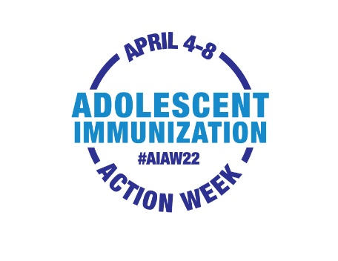

Adolescent Immunization Action Week
Sample Newsletter Content for HCP Audiences

Use or adapt this sample news content to spread word about AIAW to your network
via newsletter, email, blog or other communication channels

Adolescent Immunization Action Week gears up to get
adolescents up to date on immunizations
April 4th-8th is the first annual National Adolescent Immunization Action Week (#AIAW22). Unity® Consortium launched this initiative to bring attention to the importance of adolescent immunization and to urge health care providers and parents to get adolescents up to date on recommended vaccines.
During AIAW22, we’ll be sharing information and resources across our communications channels and we hope you will too. Research has consistently shown that healthcare professionals are the most trusted and influential source of vaccine information for parents.
Visit Unity’s AIAW campaign page for social media-ready materials and graphics you can use to communicate and draw attention to the importance of taking action now to improve adolescent immunization coverage.
Here are action ideas for AIAW to remind, recall, and schedule immunizations:
- Use electronic health records to identify patients with missed immunizations and contact them to schedule appointments
- Communicate with families about missed well visits and staying up to date on vaccines
- Make vaccination scheduling convenient for parents, e.g. offer vaccination clinics during school vacations/spring break
- Check vaccination status during all adolescent visits to avoid missed opportunities
- Make confident, presumptive vaccine recommendations, and share credible sources on vaccine safety and efficacy
- Share the #AIAW22 call to action with local organizations (health departments, schools), so they too can spread the word
Together we can help mitigate the impact of COVID-19 on adolescent immunization rates and help to prevent future outbreaks of vaccine-preventable diseases.

