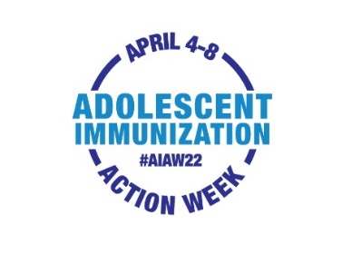
Email/Letter Template from HCP to Parent of Adolescent

[DATE]
Dear [PARENT/GUARDIAN NAME],
Adolescent Immunization Action Week (#AIAW22) is April 4th-8th. This is a great time to “spring” into action by contacting us to schedule an immunization assessment for your adolescent.
Many adolescents missed their annual checkups and immunizations during the pandemic. Making sure that your adolescent is up to date is one of the best ways we can work together to protect their health.
Vaccines are critical to protect your adolescent from serious illnesses. These include protecting against meningitis; cancers caused by HPV; tetanus, diphtheria, and whooping cough.
- Please contact us at [PHONE #] or go online at [LINK] to schedule an appointment.
Our providers and staff are committed to helping your family stay safe and healthy. We look forward to hearing from you soon.
Sincerely,

