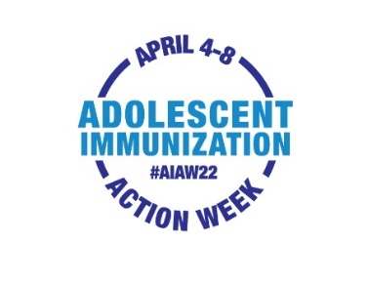

Text Message Templates from HCP to Parent of Adolescent

Adolescent Immunization Action Week is April 4th – 8th. It’s a great time to get your adolescent up to date on vaccinations. Please call us at [XXX-XXX-XXXX] to schedule an appointment.

Adolescent Immunization Action Week is April 4th – 8th. Spring break is a great time to get your adolescent up to date. Please call us at [XXX-XXX-XXXX] to schedule an appointment.

Your adolescent is due for a well visit and vaccinations. “Spring” into action and call us at [XXX-XXX-XXXX] to schedule an appointment.

We’ve missed you! Call us at [XXX-XXX-XXXX] to schedule your adolescent for a checkup and needed vaccinations.

Our records indicate that your adolescent is not up to date on recommended vaccines. Please call us at [XXX-XXX-XXXX] to schedule an appointment.

Let’s keep your adolescent healthy and protected. Your adolescent is due for needed vaccinations. Please call us at [XXX-XXX-XXXX] to schedule an appointment.

