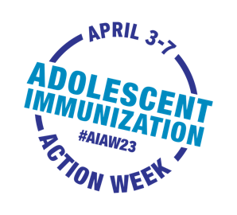
Adolescent Immunization Action Week

Sample Newsletter Content for HCP Audiences

Use or adapt this sample news content to spread word about AIAW to your network
via newsletter, email, blog or other communication channels

Adolescent Immunization Action Week gears up to get
adolescents up to date on immunizations

April 3rd – 7th is the second annual Adolescent Immunization Action Week (#AIAW23). Join us and Unity® Consortium to focus attention on the importance of adolescent immunization and staying up to date on recommended vaccines.

Parents cite their adolescent’s health care provider as the most trusted and influential source of vaccine information. Parents look to you for vaccine recommendations, to address questions, and correct misinformation.

AIAW encourages action to ensure adolescents are current on well visits and immunizations. Before and during AIAW23, we will share information and resources on Unity’s website and social media. Visit Unity’s AIAW page for social media-ready messages and graphics to help you draw attention to adolescent immunization.

Here are action ideas for AIAW to remind, recall, and schedule immunizations:
- Contact families who have missed well visits/immunizations
- Check vaccination status during all visits to avoid missed opportunities
- Deliver confident, concise, and consistent (3Cs) vaccine recommendations
- Make scheduling vaccine appointments convenient (e.g., clinics during school vacations)
- Use electronic health records and vaccine registries to identify adolescents who are not up to date
- Co-administer recommended vaccines to maximize the opportunity to keep adolescents up to date
- Share the #AIAW23 call to action with local health departments, organizations and/or schools) so they too can spread the word
Together we can boost adolescent immunization rates and help prevent vaccine-preventable diseases.

