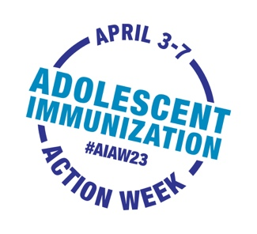
Email/Letter Template from HCP to Parent of Adolescent
[DATE]
Dear [PARENT/GUARDIAN NAME],
Adolescent Immunization Action Week (#AIAW23) is April 3rd - 7th. This is a great time to “spring” into
action by contacting us to schedule an immunization assessment for your adolescent.
Your adolescent may be due for their annual checkup and immunizations. Making sure that your adolescent is up to date is one of the best ways we can work together to protect their health.
Vaccines are important to protect your adolescent from serious illnesses. These include protecting against meningitis, HPV-related cancers, whooping cough, COVID-19 and flu.
- Please contact us at [PHONE #] or go online at [LINK] to schedule an appointment.
Our providers and staff are committed to helping your family stay safe and healthy. We look forward to hearing from you soon.
Sincerely,

