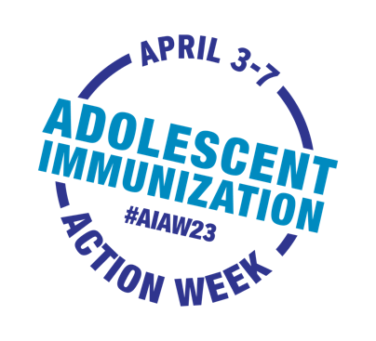
Adolescent Immunization Action Week

Sample Newsletter Content for Parent Audiences

Use or adapt this sample news content to spread the word about AIAW to your network
via newsletter, email, blog, or other communication channels

Adolescent Immunization Action Week gears up to get
adolescents up to date on immunizations

April 3rd – 7th is Adolescent Immunization Action Week (#AIAW23), a call to action urging parents to get their adolescents up to date on immunizations.

Adolescent immunizations are timed to start protecting adolescents before they are likely to be exposed to serious, potentially life-threatening illnesses, so it’s important for them to be up to date.

Some vaccines require more than one dose to provide the best protection. Each recommended dose is important, so take advantage of any upcoming school breaks or holidays to fit in those appointments.

It is natural to have questions about vaccines. Talk to your healthcare provider to get answers and make your adolescent part of the discussion.

What can you do?
Spring into action! Contact your adolescent's healthcare provider now to find out what recommended vaccines your adolescent may need and keep them up to date on their immunizations.

During AIAW23, [YOUR ORGANIZATION NAME] will be sharing information and resources on social media to highlight the importance of adolescent immunization. Please help us spread the word! Follow the conversation on [INSERT YOUR SOCIAL MEDIA HANDLES] and @unityconsortium, and use #AIAW23 to share why protecting your adolescent is important to you.

