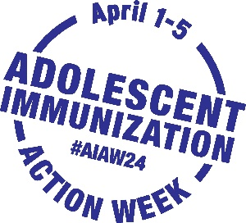

Adolescent Immunization Action Week

Sample Newsletter Content for Healthcare Provider (HCP) Audiences

Use or adapt this sample news content to spread word about AIAW to your network
via newsletter, email, blog or other communication channels

Join in to ensure adolescents are up to date on vaccines
during Adolescent Immunization Action Week

April 1–5 is the third annual Adolescent Immunization Action Week (#AIAW24). Join us and Unity® Consortium to focus on ensuring adolescents are up to date on recommended vaccines.

Parents cite their adolescent’s healthcare provider as the most trusted and influential on their vaccination decisions. Parents depend on their healthcare providers to acknowledge and answer their questions, recommend needed vaccines, and help keep their adolescents healthy.

AIAW urges you to act to keep adolescents current on well visits and immunizations. Visit Unity’s AIAW24 Partner Toolkit (password: unity) for social media-ready messages and visuals and other materials to help you draw attention to adolescent immunization. You will find information also on participating in AIAW events and ideas for spreading the word to your networks.

Here are suggested actions for AIAW to remind, recall, and schedule immunizations:
- Contact families who have missed adolescent well visits or immunizations
- Check vaccination status during all adolescent visits to avoid missed opportunities
- Deliver confident, concise, and consistent (3Cs) vaccine recommendations
- Make scheduling vaccine appointments convenient (e.g., clinics during school vacations)
- Co-administer recommended vaccines to avoid having families schedule multiple visits
- Share #AIAW24 and spread the word with health departments, organizations and/or schools
Together we can boost immunization rates and help protect our adolescents from vaccine-preventable illnesses.

