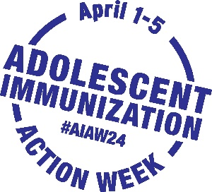

Adolescent Immunization Action Week

Sample Newsletter Content for Parent/Caregiver Audiences

Use or adapt this sample news content to spread the word about AIAW to your network
via newsletter, email, blog, or other communication channels

Prioritize protection from preventable illness
during Adolescent Immunization Action Week

Check that your adolescent is up to date on their vaccines during Adolescent Immunization Action Week (#AIAW24), April 1–5.

Vaccines are safe and effective and help you and your family avoid getting sick or reduce the severity of illness. That’s why major medical societies recommend vaccinations to keep your adolescent protected from certain illnesses including meningitis, HPV related cancers, and COVID-19.

It is understandable to have questions about vaccines. Talk with your healthcare provider to feel comfortable about the vaccines your adolescent needs to be protected. Know that adolescents want to be included in the discussion.

What can you do?

- Seek TRUSTed sources to know what vaccines your adolescent needs to be protected
- ASK questions to help with your vaccination decision
- SCHEDULE an appointment with your adolescent's healthcare provider
- KNOW where is convenient to go for vaccination

Help your adolescent by staying on TASK

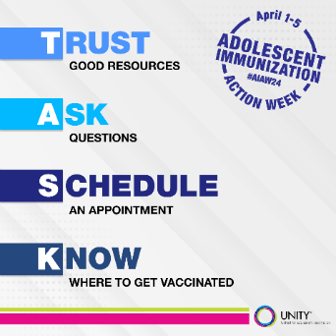

What is [YOUR ORGANIZATION NAME] doing?

During AIAW24, [YOUR ORGANIZATION NAME] will be sharing information and resources on social media to highlight the importance of adolescent immunization. Please help us spread the word! Follow the conversation on [INSERT YOUR SOCIAL MEDIA HANDLES] and @unityconsortium, and use #AIAW24 to share why protecting your adolescent is important to you.

Additional information is on Unity Consortium’s AIAW24 page.

AAP: https://www.aap.org/en/patient-care/immunizations/. AAFP: https://www.aafp.org/family-physician/patient-care/prevention-wellness/immunizations-vaccines.html. SAHM: https://adolescenthealth.org/advocacy/position-papers/. Accessed 11/15/2023.

